11/08/2024

Frank Zulski – Chair

Mark W. Hoffman – Vice Chair 2265 E. Hathaway Road

Wade Williams – Member Harbor Springs, MI 49740

Brent Shank, PE Office: (231) 347-8142

Engineer-Manager Fax: (231) 347-5787

Lisa Kleeman www.emmetcrc.org

Finance Director

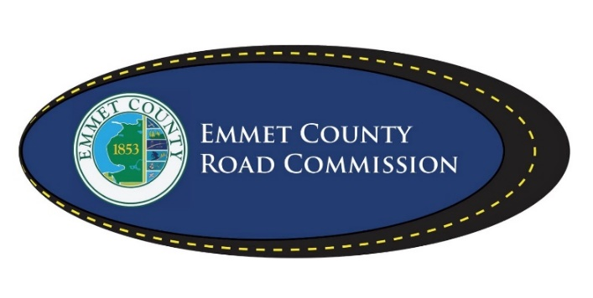

**NOTICE OF PUBLIC HEARING**

December 6, 2024, 8:15 a.m.

A Public Hearing on the Emmet County Road Commission 2025 Budget will be held on December 6, 2024, at 8:15 a.m. at the office of the Emmet County Road Commission, 2265 E. Hathaway Road, Harbor Springs, MI 49740.

EMMET COUNTY ROAD COMMISSIONERS

Frank Zulski, Jr. – Chairman

Mark Hoffman – Vice Chairman

Wade Williams – Member